Data Structure Project

Real Estate System

***Team members:***

|  |  |  |
| --- | --- | --- |
| **No.** | **ID** | **Name** |
| 1. | 42110161 | Ansar Ausama A. A. Yousif |
| 2. | 42110123 | Esraa Ahmed Saeed Abdul Samad |
| 3. | 42110099 | Reem Ayman Eissa |
| 4. | 42110089 | Salma Abdrabo Abdelbary |
| 5. | 42110142 | Rawan Elsayed Hashim |

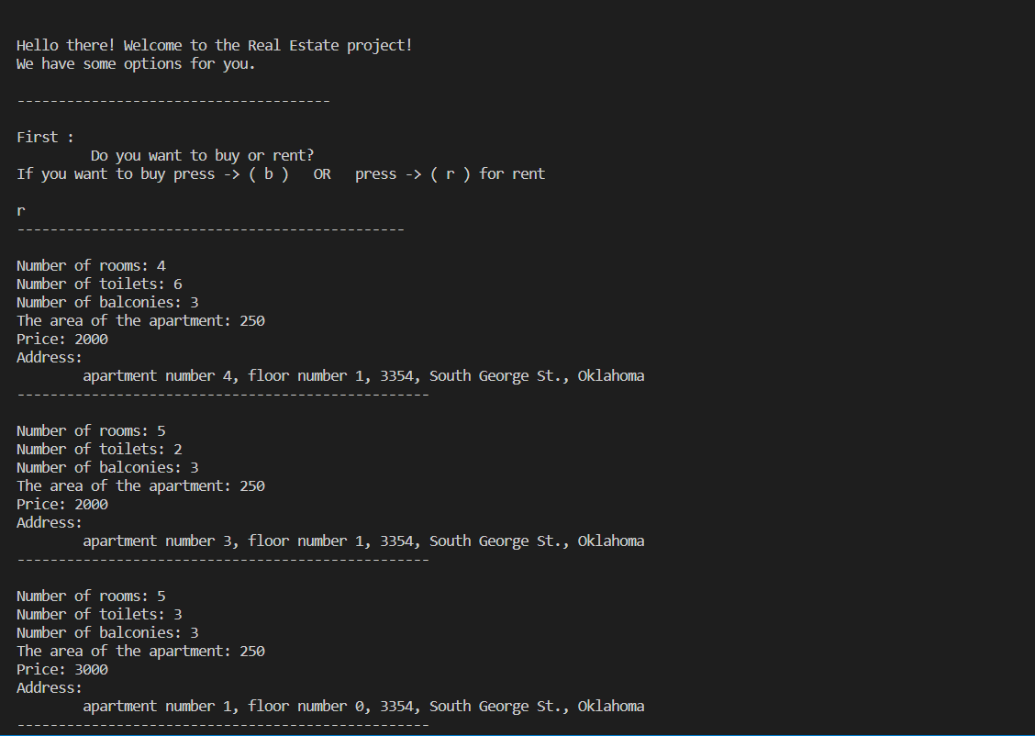The Output:

